GDD

Ozero Molytuv

THE

Hunting Knife

Lauri Salminen, Roope Veijonen, Topias Kumpulainen, Valtteri Kurhela



Helsinki Metropolia University of Applied Sciences

GDD

Date

Contents

1.1 Game overview 3

1.2 Game Concept 3

1.3 Game Genre 4

**1.4 Target Audience** 4

**1.5 Look and Feel** 4

2 Gameplay and mechanics 5

**2.1 Minigames.** 5

**Project scope** 6

**2.3 Graphics.** 9

**2.4 Gameplay and physics** 9

3 Walkthrough 10

**3.1 Disclaimer** 10

**3.2 Expirence**………………………………………………………...………….…………10

# 1.1 Game overview

The game is a 2D/2.5D Adventure game about man/woman who is trying to find knife to cut his/hers morning bread.

Story based is based on a weird volcano island. Player will be faced with pretty weird scenarios and situations throughout your journey.

# 1.2 Game Concept

Story starts with the main character trying to find his/her knife and when the player doesn’t find it the player has to go to the shop.

At the shop the player realizes he/she doesn’t have any money, so he/she has to go to “työkkäri”. At the “työkkäri” they offer the player three/~~four~~ different jobs (all the jobs are their own minigames). After this the story branches to multiple different directions.

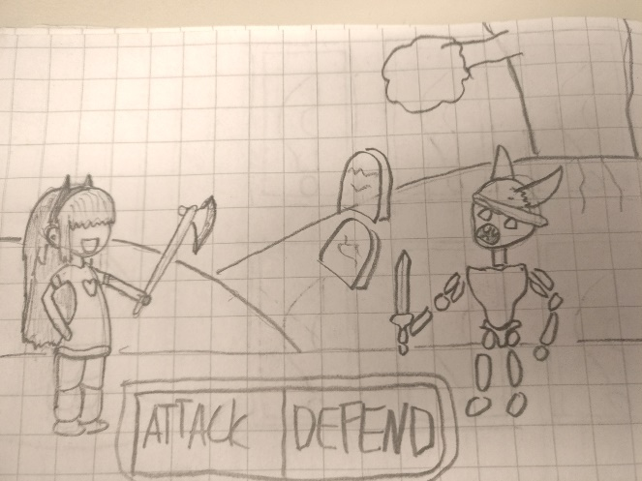

# 1.3 Game Genre

The game is an adventure game that has multiple minigames and a bit of combat elements. Most important part is the brilliant, funny and original story.

## **1.4 Target Audience**

Target audience is teenagers and young adults.

Our game is going to include some inside jokes, but we will try to keep them insignificant. Basically the game targets anyone with a good sense of humour.

## **1.5 Look and Feel**

Game should be fun and easy to play. The game aims to have super weird and wacky feel to it, leave your common sense at the start screen and you are in for an amazing ride though our crazy (in a good way) story.

~~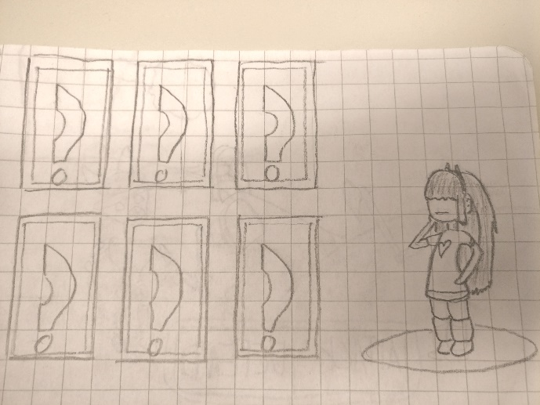~~

# 2 Gameplay and mechanics

## **2.1 Minigames.**

* + 1. Maze
* simple Maze with easy to find way out
  + 1. Simon say’s
* press the right colors in the right order
  + 1. Parking Game
* Get out of the parking lot
  + 1. Memory card Game
* Graveyards game.. Find the right bones
  + 1. Stealing
* try to steal yourself a knife
  + 1. Fishing
* Fish a treasure or just a fish
  + 1. Platformer
* You gotta stop the music and jump to the radio tower
  + 1. Gamble (<http://oldschoolrunescape.wikia.com/wiki/Rune-Draw>)
* Arcade gambling game

## **Project scope**

Plan is to have 12-14 locations each of them works also as a level.

* + 1. Graveyard’

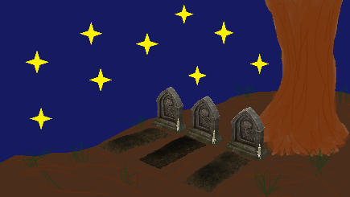

Dark Place with a fun memory game

* + 1. Työkkäri

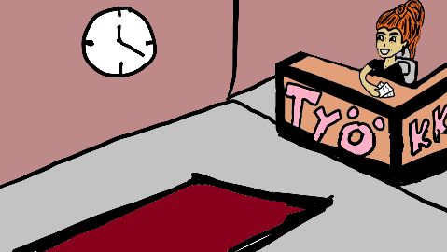

Place where you get the first 3 job offers

* + 1. Kauppa

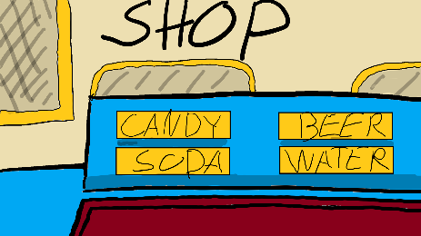

Islands best place to buy knifes

* + 1. Burger Queen
    2. Swamp
    3. Fishing hut

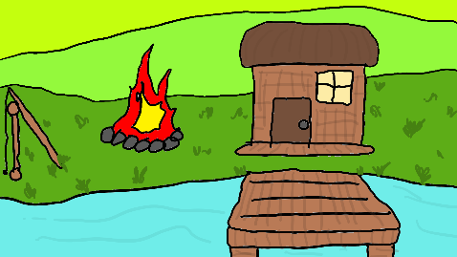

Drunk fisherman’s cottage

* + 1. Media tower
    2. Big city hotel
    3. Evil Castle

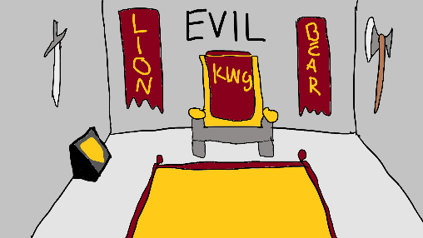

Ruler of the island sits here

* + 1. Wild West camp
    2. Dragon’s nest
    3. Casino

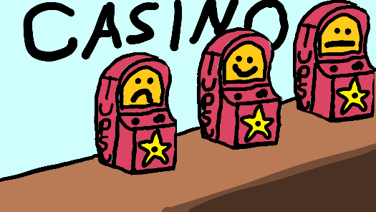

Fancy casino also islands only place to have fun

* + 1. Space Station
    2. House

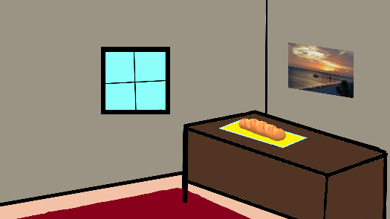

Ozeros own house

* + 1. Gym

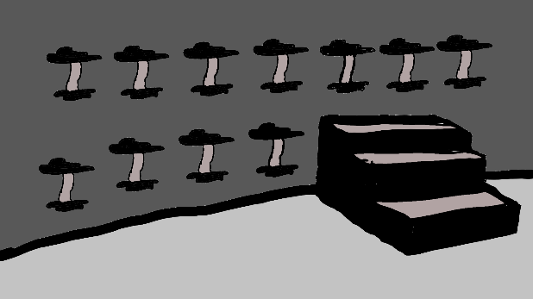

Place where Ozero might go and workout

## **2.3 Graphics.**

Graphics will include Unity's default graphics with some of our own designs.

## **2.4 Gameplay and physics**

Physics included in the game include at least solid objects and movement.

The game is going to use really simple controls, moving with arrow keys. World map works with click-to-move. Controls might change a bit for some minigames.

Example the memory game will feature point and click while our new maze game will feature simple controls with buttons.

**2.5 Karma System**

Throughout the game you make different choices. These choices either give the player good, bad karma or give nothing. Players karma affects the gameplay in various ways.

There are 3 different states you can be on: the neutral karma, evil karma and good karma. all of them affect the games dialog in different ways.

# Walkthrough

## **3.1 Disclaimer**

As the game has multiple mini games and routes the player can take. There is no “right” way to play the game.

**3.2 Experience**

The game is pretty linear in the end your dialog will change and the outcome maybe different but when looking at the games core it will be the same awesome experience for everybody.